Sprint 1 Plan

Product Name: Smart Budget

Team Name: FTX

Sprint Completion Date: 7/10/23

Revision Number: 1.0

Revision Date: 6/30/2023

Goals:

1. Be able to handle user authentication and edit user profiles.

2. Be able to add income and expenses.

Task Listing, organized by user story:

User Story 1.1: As a user, I want to create a profile so that I can see my personal information.

1. Build a feature that creates an account, 4 hours
2. Authentication methods, 4 hours
3. Build a feature to handle user information (First name, Last name, Email address),

Total Hours:

User Story 1.2: As a user, I want to log in easily so that I can access my information

1. Contain a username/password manager,
2. Create a login page, hours
3. Basic homepage, 6 hours

Total hours:

Team Roles:

1. Kamal Shamsi: Product Owner / Developer
2. Brian Le: Scrum Master / Developer
3. Brian Quach: Scrum Master / Developer
4. Abdullah Riaz: Developer
5. Khoa Le: Developer
6. Akshayraj Jeripotula: Developer

Initial Task Assignment:

1. Brian Quach: 1.1 - Task #5, 6
2. Brian Le : 1.1 - Task #1
3. Abdullah Riaz : 1.2 - Task #6
4. Khoa Le : 1.1 - Task #1
5. Kamal Shamsi : 1.1 - Task #3
6. Akshayraj Jeripotula: 1.2 - Task #5

Initial burnup chart:

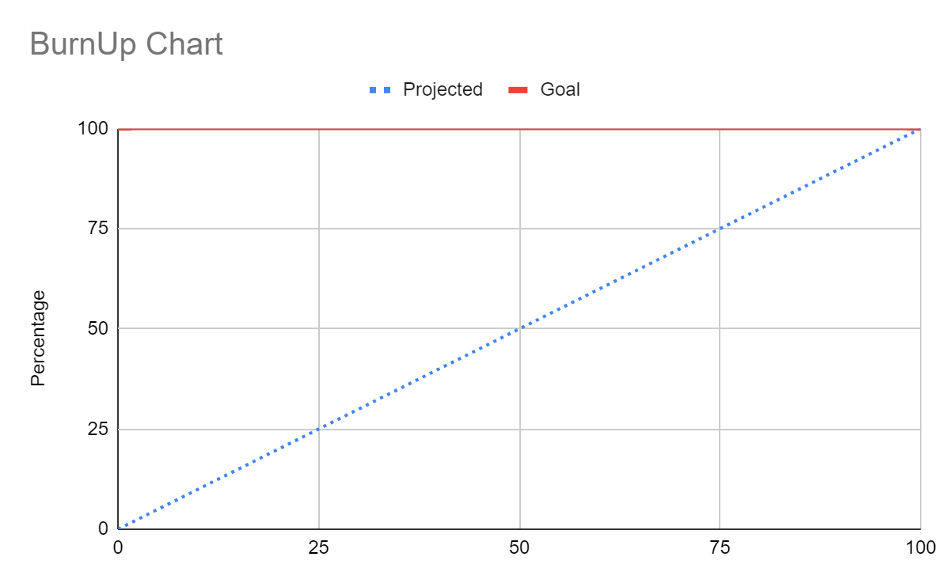

Scrum Board:

Sprint 1 | SmartBudget

| User Stories | Tasks not started | Tasks in Progress | Tasks Finished |
| --- | --- | --- | --- |
| Profile Creation | Account Creation Account Authentication Parse Login Info |  |  |
| Login | Store Login Info Login Page Homepage |  |  |

Scrum Times:

1. 7/4 TA: ?
2. 7/6 TA: ?
3. 7/7 TA: ?